- ERC Final Proposal
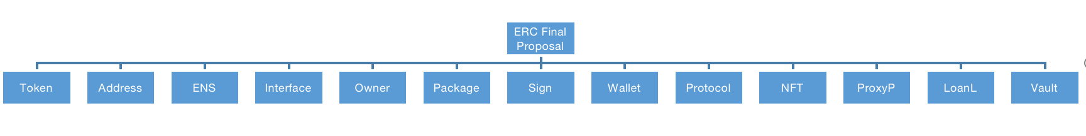

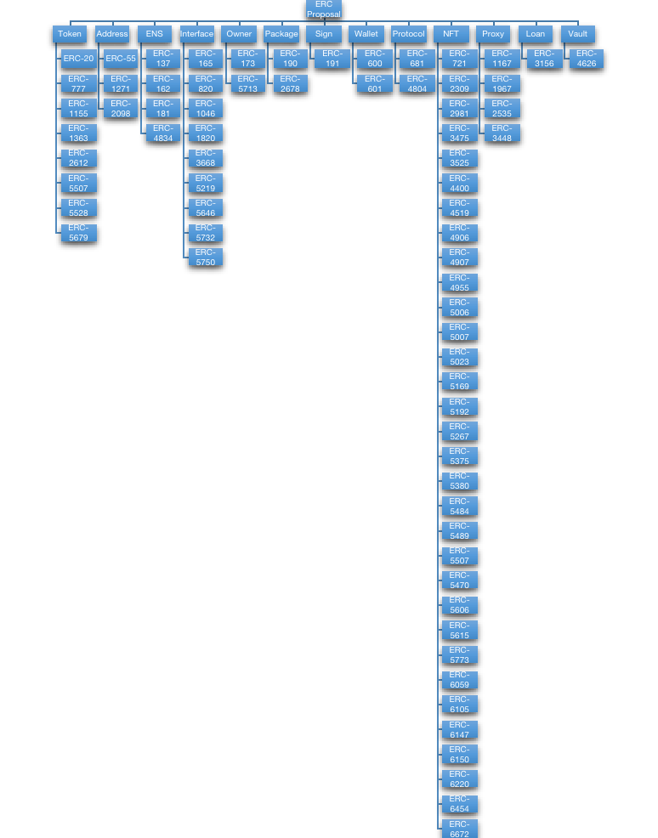

- 漏洞分类（基于大类）

- 修复性质ERC

ERC Number | Purpose
ERC-223 | 修复ERC-20中代币丢失，转账和交互的效率低等问题
ERC-1234 | 降低Gas成本以及限制某些操作的资源消耗来提高网络的安全性和可扩展性
ERC-1271 | 验证外部合约对消息的签名,从而防止恶意合约的攻击，提高以太坊生态系统中合约的安全性
ERC-1283 | 改进合约执行过程中的存储成本,减少由于存储操作引起的安全漏洞
ERC-1820 | 修复ERC-820在调用ERC-165的逻辑性不兼容问题

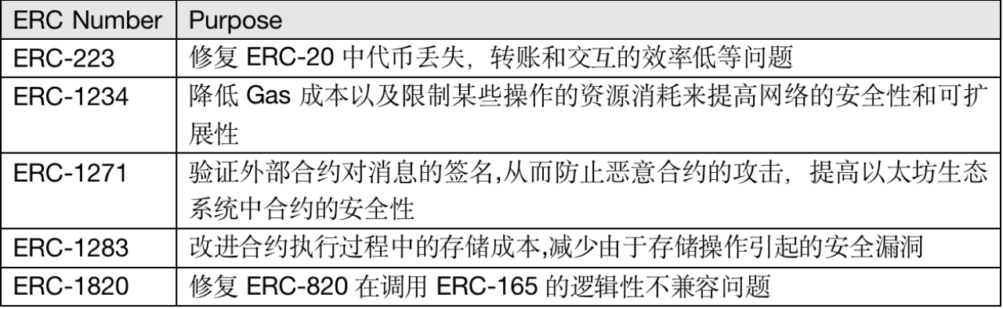

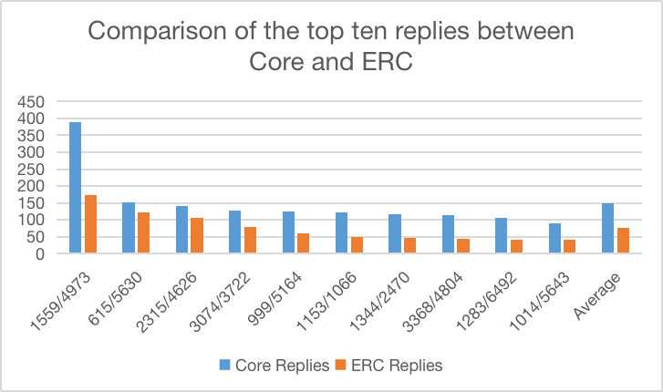
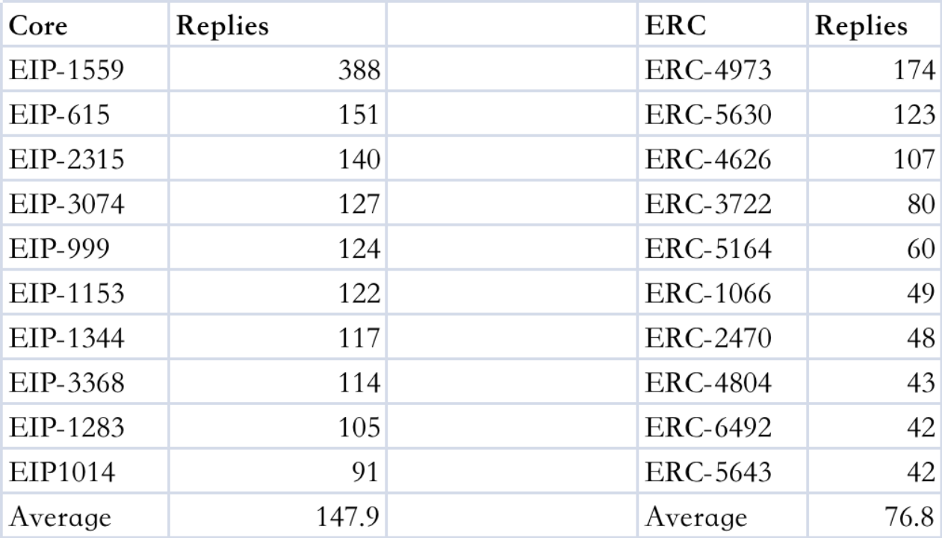

Overflow | Logic issue | Access control | Lack validation
ERC-137 | ERC-137 | ERC-137 | ERC-137
ERC-721 | ERC-3525 | ERC-1155 | ERC4337
ERC-4337 | ERC4337 | ERC-734 | ERC-191/712
 | ERC-162 | ERC-162 | ERC-777
 |  | ERC-721 | ERC-1820
 |  | ERC-777 | ERC-1967
 |  | ERC-3525 | ERC-3525
 |  | ERC-4337 | ERC-4626
 |  |  | ERC-4337
 |  |  | ERC-721

 | Overflow | Logic issue | Access control | Lack validation
occurrence frequency | 1 | 105 | 38 | 41

 | Overflow | Logic issue | Access control | Lack validation
occurrence frequency | 1 | 105 | 38 | 41

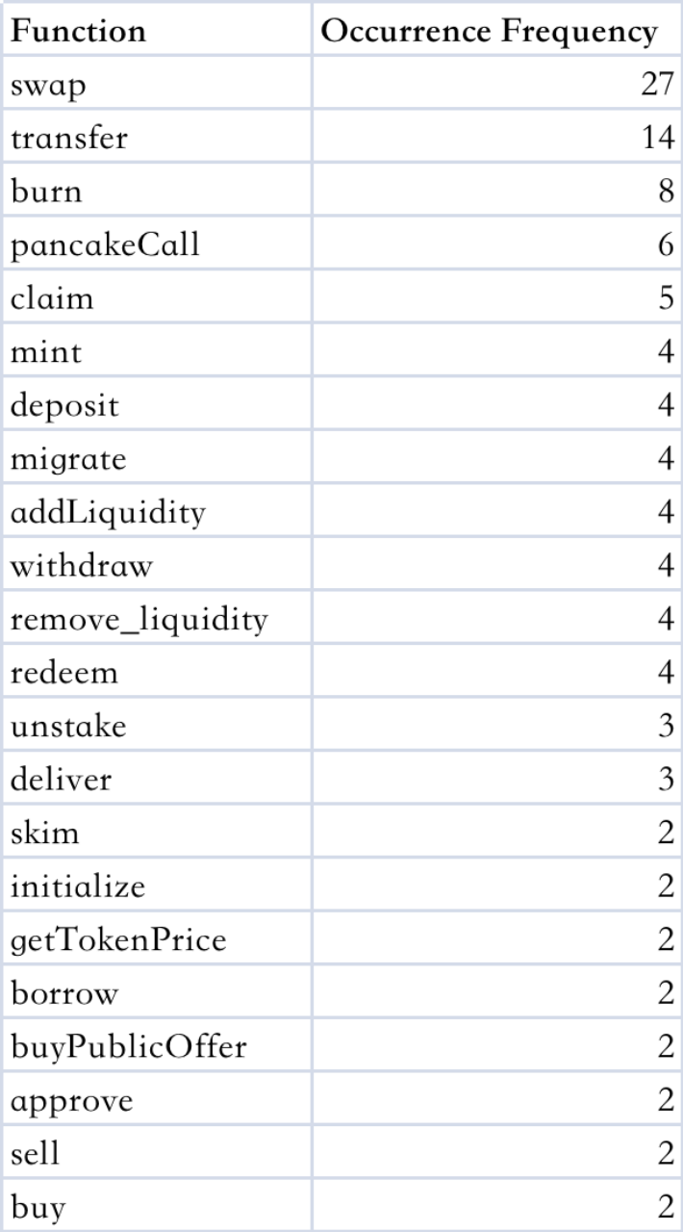

Number | Issue Title | Category
137 | Memory corruption in Buffer | Overflow
137 | SimplePriceOracle.price is susceptible to integer overflow | Overflow
137 | ETHRegistrarController.register is vulnerable to front running | Logic Issue
137 | SOA record check on the wrong domain | Validation
2098 | ECDSA signature malleability | Validation
3525 | ERC-721 token receiver contract may not be able to receive ERC-3525 tokens due to an issue in the _checkOnERC721Received() function | Logic Issue
3525 | ERC-3525 receiver contract may not be able to receive ERC-3525 values due to an issue in the _checkOnERC3525Received() function | Logic Issue
4337 | Deposit manipulation | Validation
4337 | Incorrect prefund calculation | Logic Issue
4337 | Paymasters can spend locked stake | Access Control
4337 | Token transfers may fail silently | Validation
4337 | Incorrect gas price | Validation
4626 | Vault deposits can be front-run and user funds stolen | Logic Issue

Issue Title | Frequency | Category
Lost tokens | 3 | Logic Issue
Front run | 2 | Logic issue
Incorrect calculation | 2 | Validation
Variable Overflow | 1 | Overflow
Memory Overflow | 1 | Overflow
Weak crytpo | 1 | Validation
Deposit manipulation | 1 | Validation
Privileged function | 1 | Access Control
Wrong check | 1 | Validation

数据来源 | 数据内容
Ethereum Improvement Proposals | EIP提案以及Security Considerations
安全公司审计 | Consensys, Salus, Iosiro, Hacken, OpenZeppelin, 和 Solidity Finance等公司针对ERC以及相关应用的审计报告
历史EIP安全问题 | DeFiHackLabs中历史ERC应用的被攻击事件
安全研究文章 | GitHub和Medium等平台针对ERC提案的安全研究文章
会议和期刊论文 | Arxiv和CMLAI等学术平台中针对ERC及应用安全的学术论文

